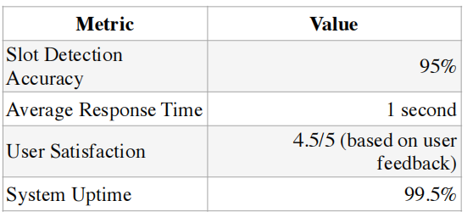

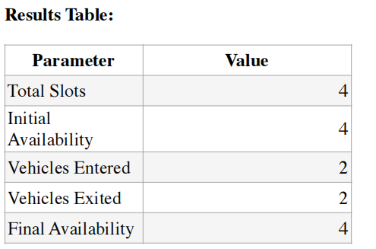

**Problem Addressed:** Inefficiency in parking slot detection and real-time updates.

**Achieved Results:** Accurate detection (95%) and immediate updates ensure reduced time

for searching for parking spaces.